Making Connection of Source table in IICS

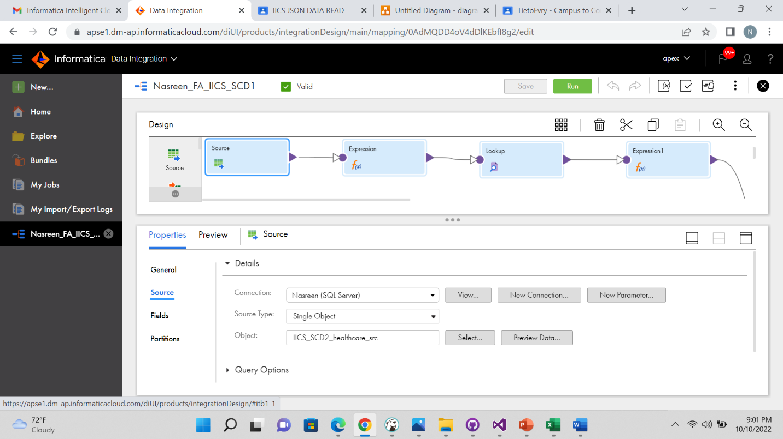

Creating output column in expression tool

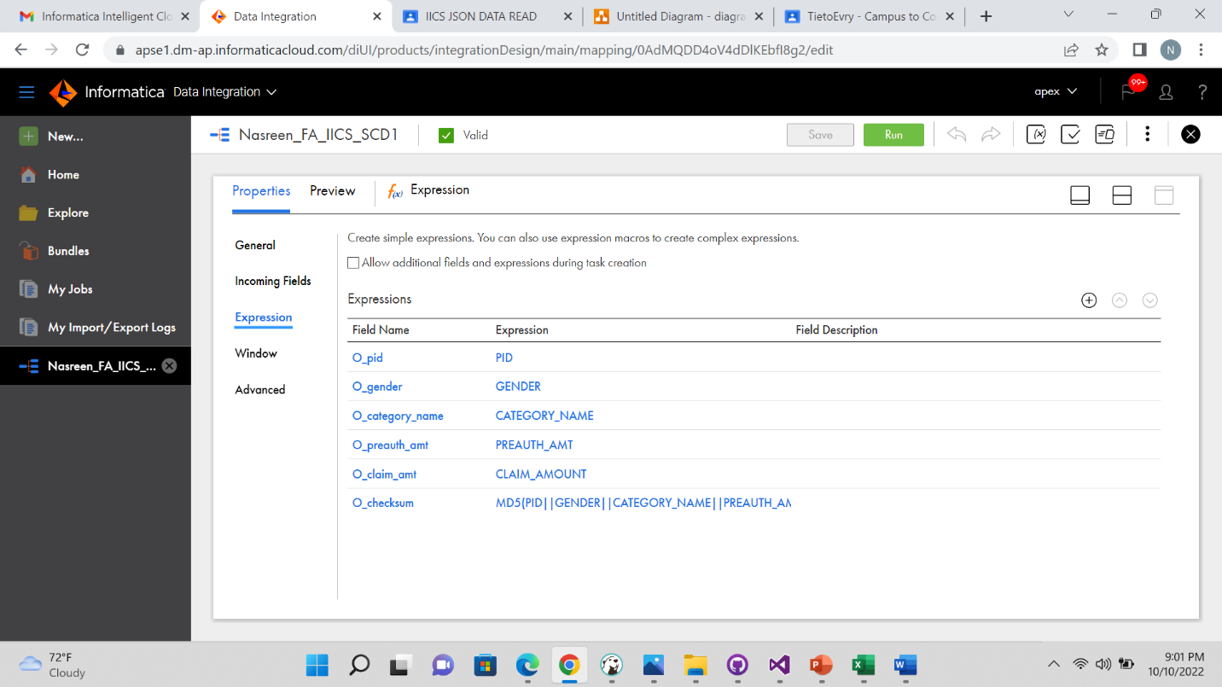

Giving target table connection in lookup

Assigning Lookup condition with source and target column

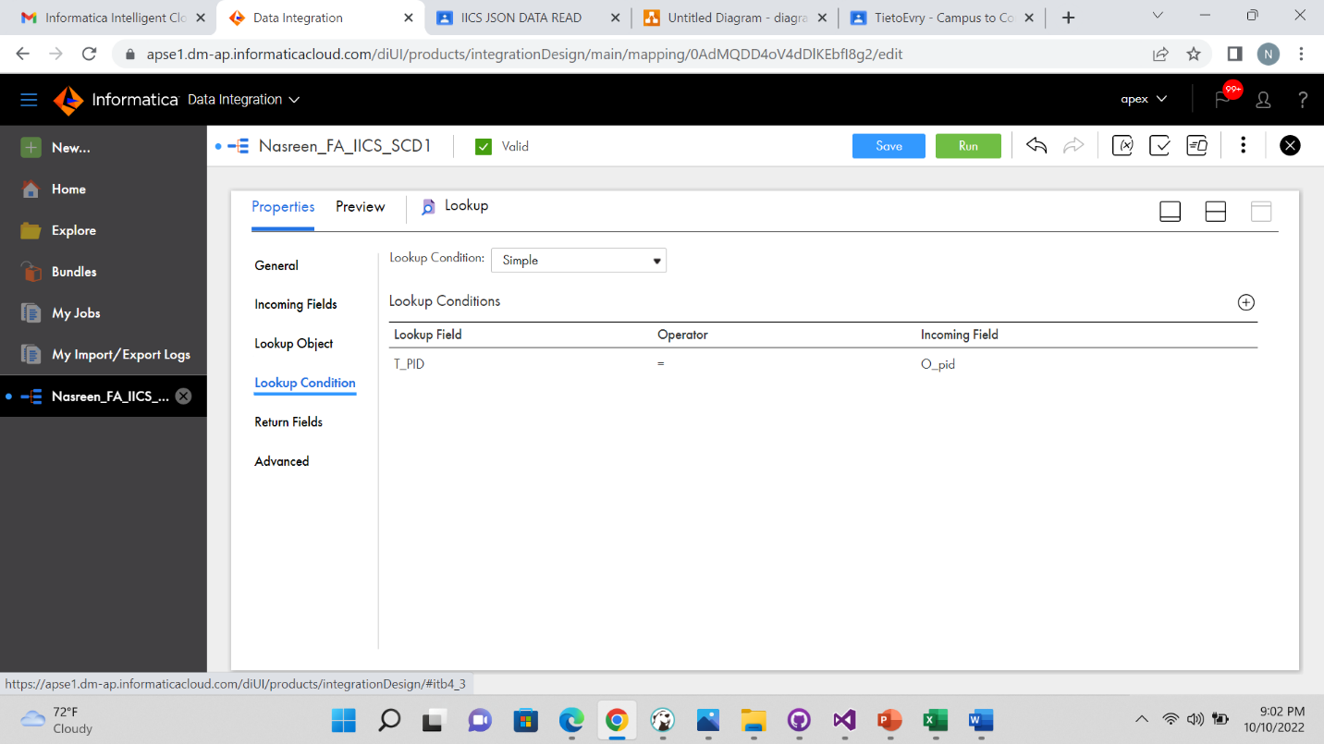

Pass the data from from lookup to expression transformation create an output field flag and assign the below field expression to flag the records.

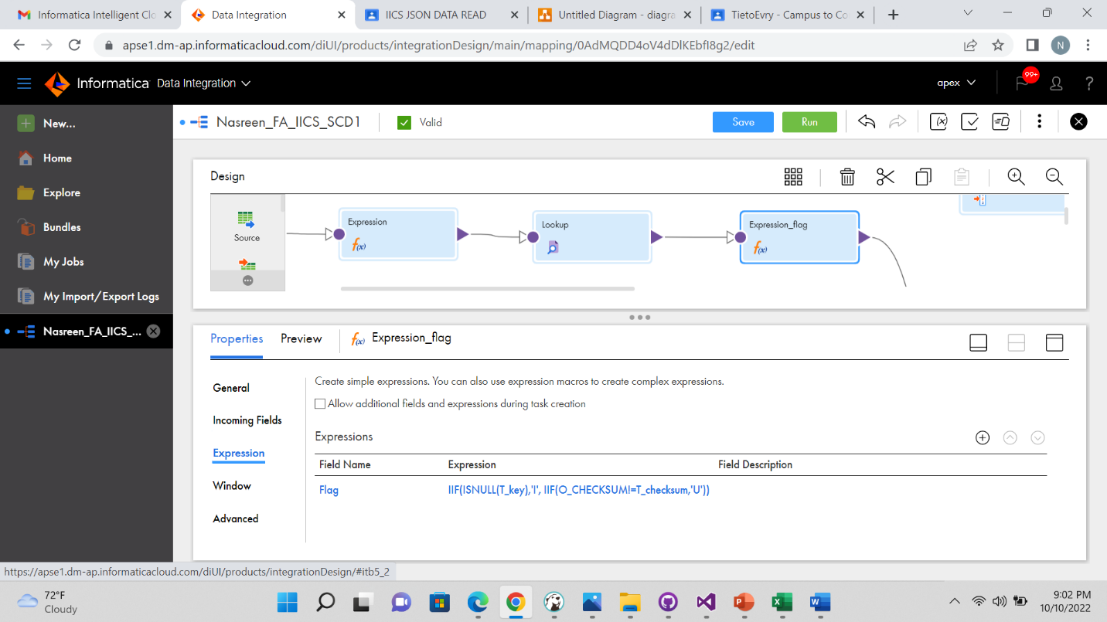

Create two groups in Router to perfrom insert operation and insert update operation

In Sequence transformation disable the incoming fields

Take an Expression tool and make connection from sequence and router to expression tool and assign T_key column to nextval

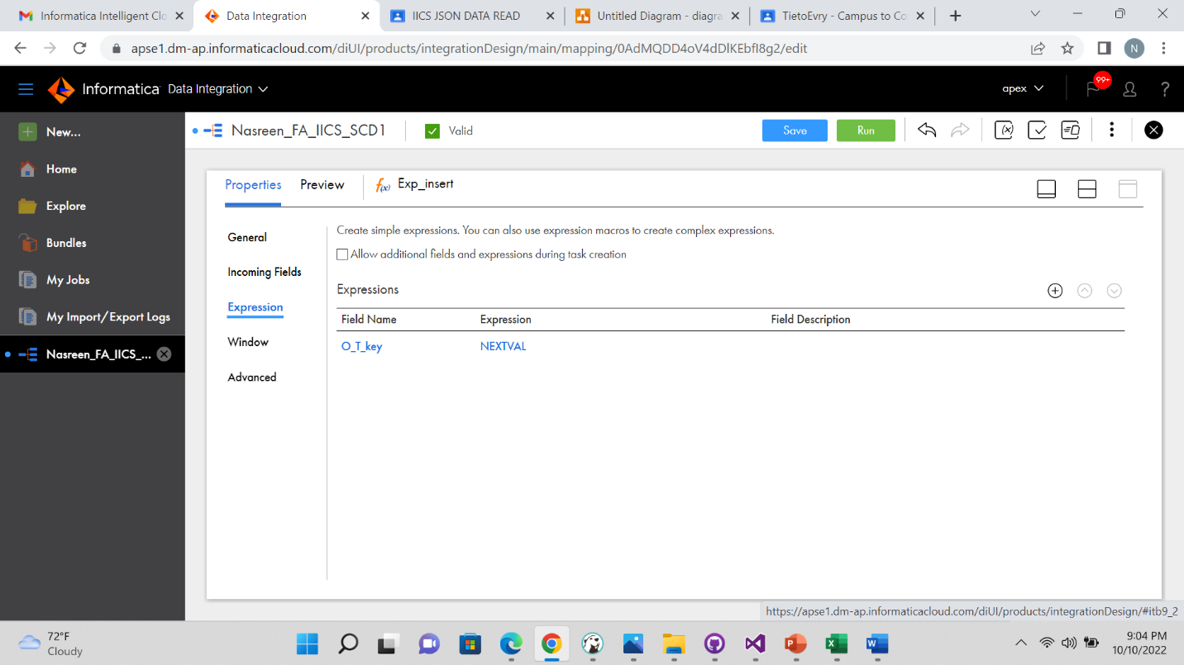

Make Target connection by choosing target table

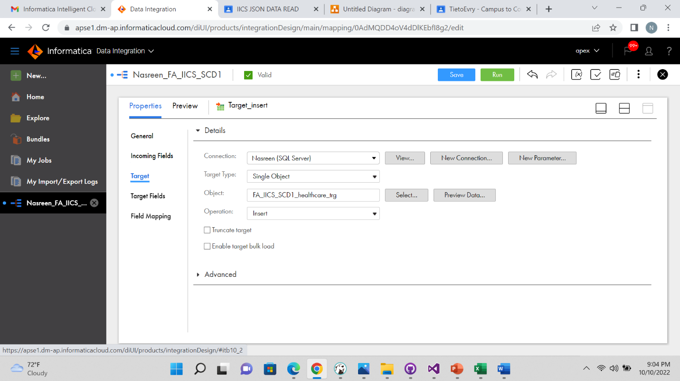

Do the field mapping in insert target

Make connection from router and sequence to Target-update tool and make target table connection.

Do the field mapping in Target-update table

After Saving mapping run the mapping to get output

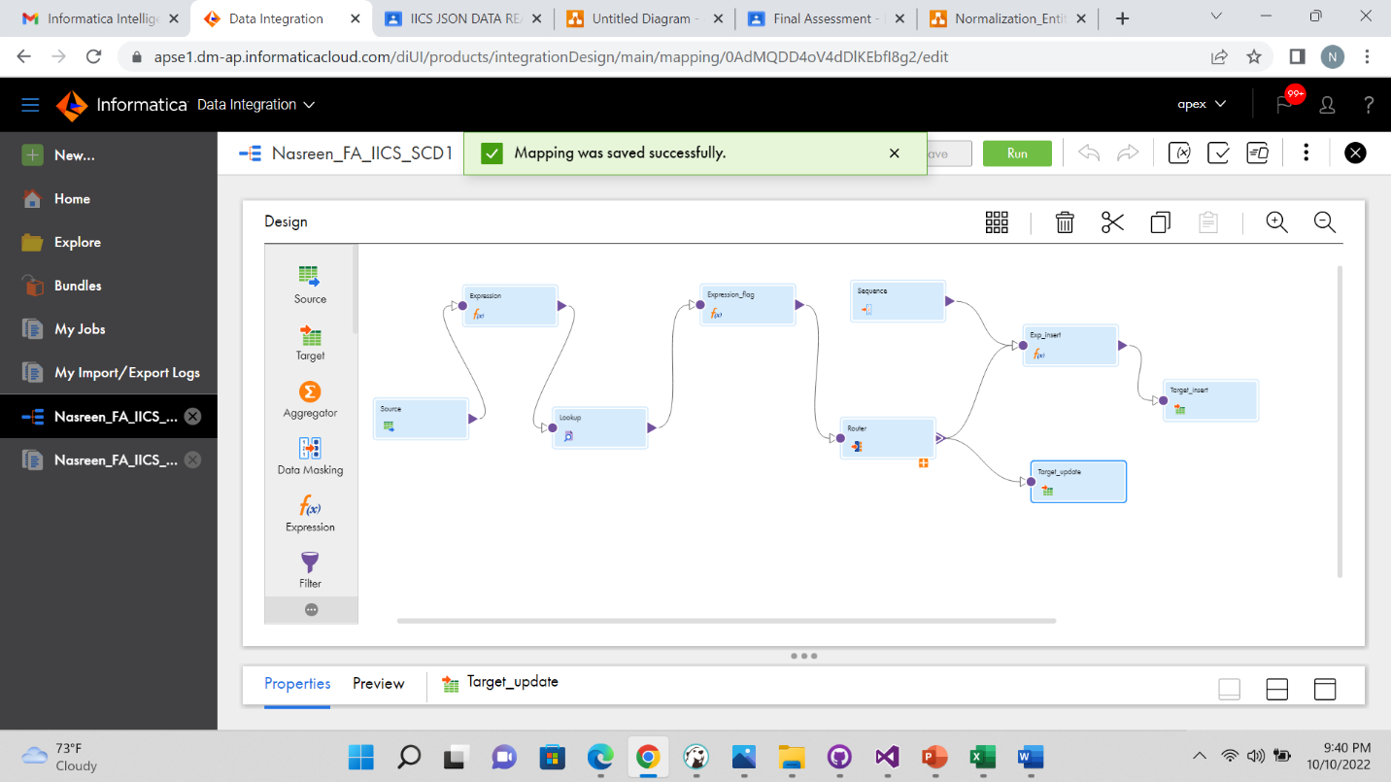

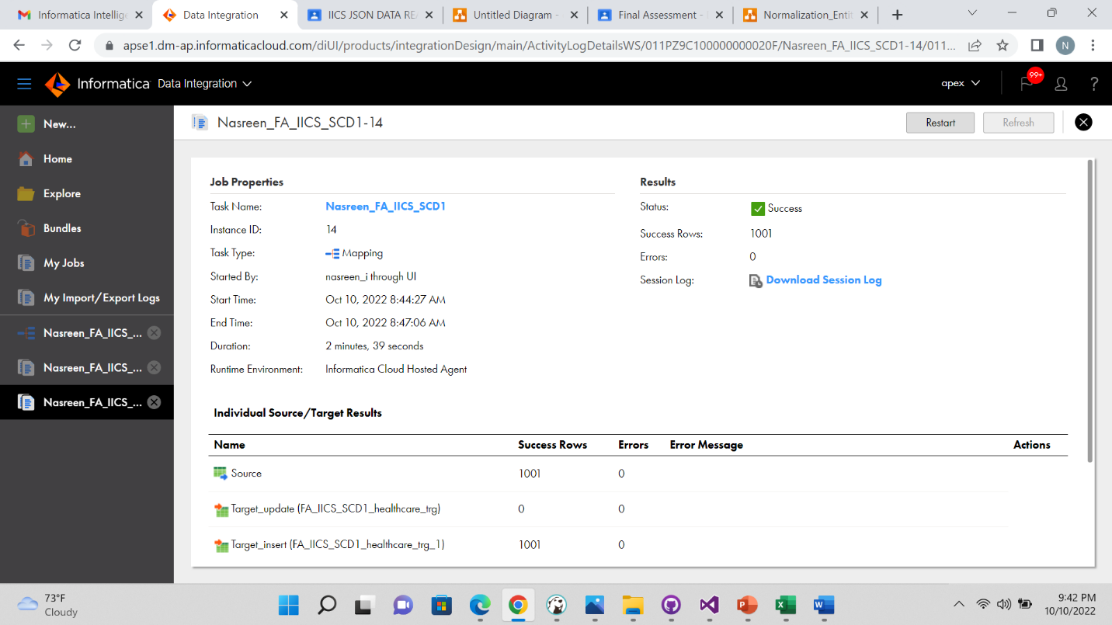

Target table After running the mapping in iics

Now update any column of the source table and run the mapping

Updated row appears in the table.

